**NEWSLETTER**

L I F E S T Y L E

O C T 2 0 2 4

CHILD HAS TO BE EDUCATED BECAUSE HUMAN WITH EDUCATION THERE IS NO LIFE ,EDUCATION IS MOST IMPORTANT THING THAT EVERY ONE WANTS TO LEARN

EVERY ONE HAS THERE DREAM TO ACHIEVE THERE GOALS SO,EVERY CHILD WANTS TO EDUCATE

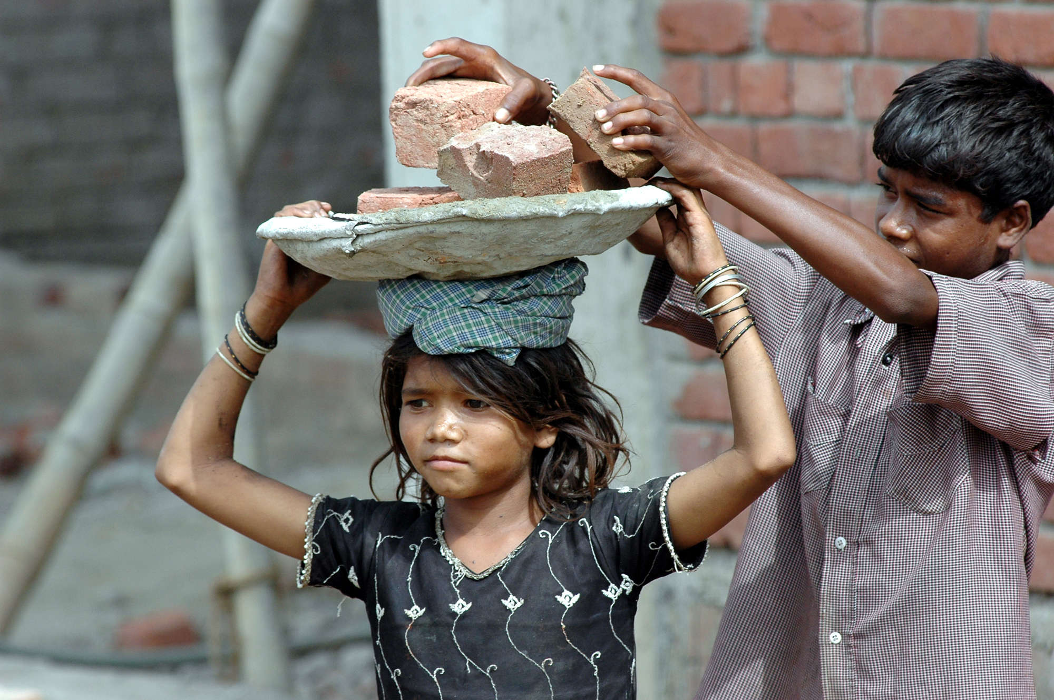

ABOUT CHILD LABOUR

CHILD LABOUR IS A RISING CRIME WHICH FORCE SMALL CHILDREN TO DO PAID WORK IN A SMALL INDUSTRY ,FACTORIES , BUSINESS , HOUSEHOLD ,ETC…,

CHILD LABOUR EFFECTS THE GROWTH AND DEVELOPMENT OF CHILDREN IN EVERY ASPECT THET IS PHYSICALLY ,SOCIALLY , MENTALLY CHILD LABOUR IS A NATIONAL ISSUE

**Ratan Tata (1937-2024):** Ratan Tata, the former chairman emeritus of Tata Sons, India's largest conglomerate, passed away on Wednesday at 86. Tata was a respected businessman and philanthropist who made significant contributions to India and the world.

* The day I am not able to fly will be a sad day for me."
* "Power and wealth are not two of my main stakes."

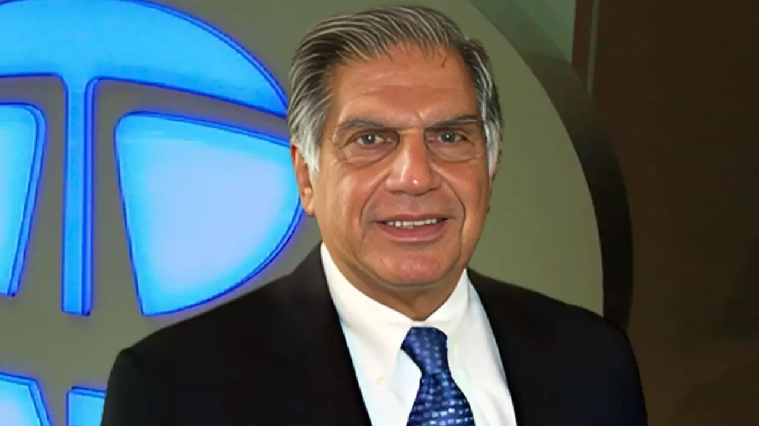

ABOUT THE GREAT PERSONALITY

RATAN TATA